Please attach digital photo in this box.
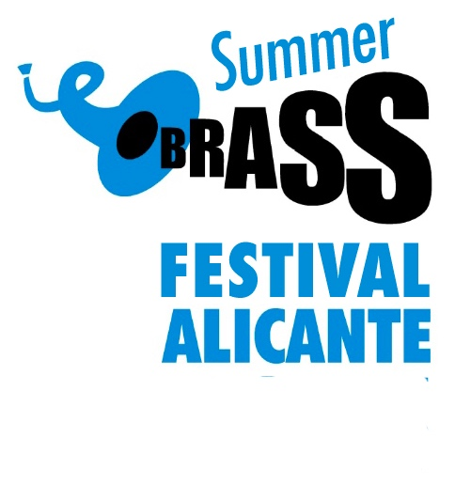
Registration Form

VII International Summer Brass Festival Alicante 2019

First and last name of student
Postal address
(street, post code, city, region, country)
E- mail address
Passport or national ID #
Date of birth
Instrument
Telephone numbers
T-shirt size ( S,M,L,XL)
Qualifying discount info.
Employer or place of study
Current instructor

*Register by email at the following address: office@brassacademy.com

Payment of the course fee :
Account holder : Brass Academy Alicante
BANCO ING : ES21 1465 0100 9119 0050 7169
International transfers:
IBAN :ES21 1465 0100 9119 0050 7169
BIC/SWIFT code: INGDESMMXXX
*When making the transfer, please remember to specify:
Summer Brass Festival + student’s complete name.
And please send a copy of the payment receipt to: office@brassacademy.com
*We ask that you please attach your current musical CV to this registration form.
* Once you have paid the fee for attending the course, the money will not be refunded, as places in the course are limited, and the payment of the fee confirms reservation of a place; exceptions will be made in case of illness, pending receipt of a medical certificate. Participation is granted strictly in the order in which registrations are completed (on a first come-first served basis).

Web : www.alicantebrassfestival.com
Brass Academy Alicante www.brassacademy.com (+34) 658 57 51 36

